Final Survey Project – Freedom of Choice
Excellent Student
March 15, 2020
MATH 130L: Introduction to Statistics
Marist College

The topic of my survey, “Freedom of Choice” was to understand how many voters that voted in the 2016 elections changed party line votes in 2018. I am interested in this topic because I think it may be an indicator of the way the nation will vote in the 2020 election. My goal is to rebuild my trust in my nation and see a potential shift in views. The population that I plan to survey are all US voters. I will use public data records from unbiased voter tally records to conduct my survey. This seems like the most accurate way to collect the data. The main information I will need to collect is data both for 2016 and 2018 elections, the parties voted for and projections for 2020. For categorical data, I will need to provide tables to interpret the data.
I found that most voters who voted for a particular party in 2016, voted for that party in 2018, and plan to vote that same party in 2020. However, those that did not vote previously, were more open to voting in 2020 and for the party not currently in power.
In my effort to make the survey anonymous and not lead respondents one way or another, I think I made my questions too broad.
The challenges I faced in completing the project included selecting the right survey provider so that I did not have to pay a hefty price to distribute the survey, and the second challenge was getting people to fill out the survey. I overcame these challenges by asking for help from my professor, who offered other alternatives for a survey provider and from my class, who completed the survey.
What I’ve learned from completing this project is that I need to work backwards if I ever conduct a survey. I need to think about what answers I would expect to get and what answers would surprise me. Based on that, I need to frame my question with the intent to get the answer, but without leading the respondent on way or another.
Some of my findings showed that in 2016, an even number of respondents voted for Democrats and Republicans during the 2016 election – 40% for each party and 20% for ‘Other’. When looking at the 2018 elections, votes for Republicans dropped by 5%. However, those votes were transferred to a party other than the Democrats by our respondents.
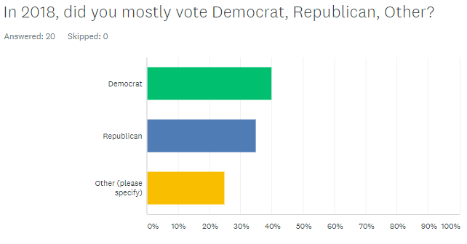

Additional questions revealed that while the projected 2020 votes look to remain the same for Democrats, the Republican party may lose 10% of votes to the “Other” party, which can be made up of anything from Working Party to Independents to write-ins.
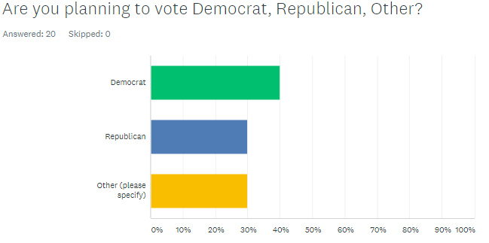
The one thing that did surprise me with the survey results is that there are people that are still unsure whether they are voting in 2020 or not. For some reason, I was positive that almost everyone saw the importance of voting after some of our recent elections. This leaves me wanting to dig deeper into this aspect of the survey. Follow up on how many people will be voting and why or why not.
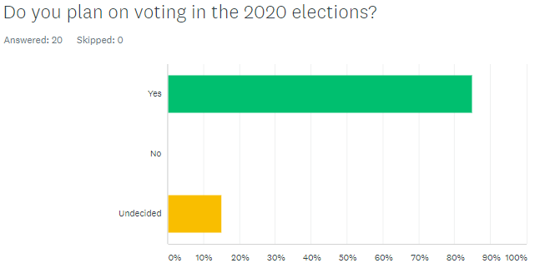
In conclusion, the survey findings were insufficient to prove that voters have changed their voting decisions by party from 2016 to 2020. Upon reflection, questions should have been set up to capture the answer to switching parties and the party they are switching to/from in one answer.

